# 1.0 Introduction

The University of Zimbabwe has since undertaken the mandate to involve its students on the implementation of Education 5.0 where a student is supposed to be characterized by the integration of advanced technologies like Artificial Intelligence, Internet of Things and Virtual Augmented Reality among other technologies. Education 5.0 enforces the student to pursue personalized learning, immersive experiences, decentralized credentials, smart classrooms, lifelong learning, accessibility, and teacher support. In support and practise of the implementation of Education 5.0, Smart Tech Cluster is undertaking the following innovations as a way of improving the society in which the University students relates with, below are applications which are being developed and attached to this document are two apk installation files for the two applications with instructions on the read me file.

**Smart technology applications to address mental health problems at the university of Zimbabwe.**

**Walter Chandiringa R168783E**

**Praise Mukono R229264Z**

**Tadiwa Chimhungwe R224025K**

**Gamuchirai Chirata R229254Z**

**Introduction.**

Mental health problems, also referred to as mental disorders or mental illnesses, encompass a wide range of conditions that affect a person’s thoughts, emotions, behaviour, and overall well-being[1][2]. These conditions can significantly impact an individual’s ability to function in various aspects of life, including relationships, work, and day-to-day activities (Static mental manual disorders American Psychiatric Association, 2013)

Mental health problems are highly prevalent worldwide with millions of people affected by them. They can occur in individuals of any age, gender, socioeconomic status, or cultural background. Some of the most common types of mental health problems include:

Depression: Depression is characterized by persistent feelings of sadness, loss of interest or pleasure, changes in appetite or sleep patterns, low energy, difficulty concentrating, and thoughts of self-harm or suicide[3].

Anxiety disorders: Anxiety disorders involve excessive and irrational fear or worry that can interfere with daily life. Examples include generalized anxiety disorder, panic disorder, social anxiety disorder, and phobias[4].

Bipolar disorder: bipolar disorder, previously known as manic-depressive illness, involves extreme mood swings that alternate between periods of mania (elevated mood, increased energy) and depression.

Post-traumatic stress disorder (PTSD): PTSD can develop after experiencing or witnessing a traumatic event. It is characterized by intrusive memories, flashbacks, nightmares, hypervigilance, and emotional distress.

Eating disorders: eating disorders, such as anorexia nervosa, bulimia nervosa, and binge-eating disorder, involve unhealthy behaviours and attitudes towards food, weight, and body image.

Attention-deficit/hyperactivity disorder (ADHD): ADHD is a neurodevelopmental disorder characterized by persistent patterns of inattention, hyperactivity, and impulsivity that can interfere with functioning and development.

**Background.**

The students at the University have mental problems that vary from financial problems, family problems, relationships problems and even educational problems. Due to the circumstances of the environment that surround them such fear of societal judgment and peer pressure other students resort to drug abuse in looking for ways to help themselves out or gang related activities. Most students have no one to talk to hence results in suffering with mental health problems which can lead to suicide.

**Goal of project**

To aid people who have mental health problems and help to better their mental health, to help remove the stigma and misconceptions about mental health problems and generally help break the silence.

**Objective.**

The primary aim of the project is to make awareness and offer aid or assistance to mental health issues especially amongst university students and the objective of providing intervention strategy.

1. Raise awareness on mental health issues.

2. To help students seek help on mental health issues.

3. To Address mental health issues that affect students

**Justification**

Mental health in Zimbabwe is under reported, suffers from lack of reliable data, remains stigmatized and is rarely acknowledged. Challenges about mental health which include depression, anxiety and suicide continue to be misunderstood and or associated with negative connotations in Zimbabwe. According to the study by the UN in Zimbabwe in partnership with ministry of health and childcare it states that morbidity and mortality rates due to mental health issues are on the rise. Individuals with mental health issues are highly stigmatized even by medical professionals due to lack of awareness and misconceptions about causes of mental health issues. In the process trust is built as there is a sense of confidentiality and trust for the students is assured as there is a lot more privacy and understanding between the two and in turn help in breaking the silence on mental health issues

**About the project.**

We will require a partnership with the University of Zimbabwe to develop a customized mobile application which will have the following capabilities:

* Offer support services like counseling in moments of weakness.
* Check up on students daily and monitor their well-being.
* Motivation and devotional quotes that encourage to those who have experienced mental health issues.
* Give daily updates and monitor the mental health of the students.
* Provide information about mental health and generally raise awareness.
* Collect data for analysis on mental health issues.
* Provide safe space for students affected by mental health issues.

**Expected outcomes**.

* More students engaging and getting mental help.
* Reduce fear and distrust from students.
* Empower students to become better visions of themselves.
* Help break the silence and stigma about mental health.
* Help raise awareness on the dangers of suffering from mental health if unattended.

**Intervention.**

For the project to work the University of Zimbabwe and university professionals who represents the interests of students will need to be engaged. The mobile application can act as a platform for student support service as students can seek counseling, information on mental health issues as well as a mental health assessment platform. With the development of such an application the University can be better placed to help students who are not willing to admit that they have mental health issues by doing it online. The aim also is to remove the stigma and misconceptions on mental health and to have more students come forward and help fight mental health.

# 2.0 Mental Healthcare Companion

Mental Health Care application is an application designed to cater for various students at the University of Zimbabwe with various mental health problems, from depression, drug addiction among other mental health problems. It is still being developed and below are some of the features which it is now equipped with.

# 2.1 App Shortcut

An apk file for the app was derived by the developer for testing purposes, physical installation on android phones was done to experience the work developed thus far. Below is the image of the mental health care application installed on an android phone.

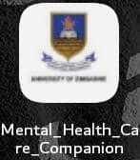

*Figure 2.1: Mental Health Care App Shortcut*

# .2 Splash Screen

This is the screen which opens upon clicking the app shortcut on your android phone

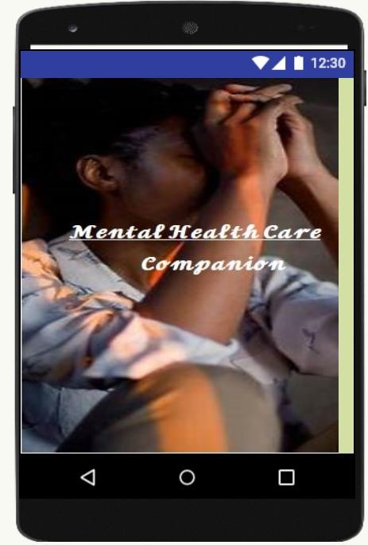

*Figure 2.2: Mental Health Care Splash Screen*

# .3 Mental Health Care Home Screen

This is the home screen of the Mental Health Care app; it is coupled with inbuilt random health quotes which are responsible to cheer up the user as the user opens the application

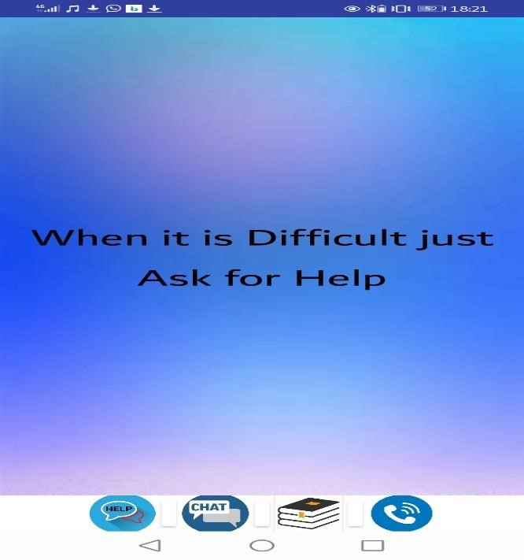

## Figure 2.3: Auto Generative Health Care Quotes Home page

### 2.4 Menu Tab

Below is the menu tab which the user uses to navigate the menu:

1. Help Tab
2. Chat Tab
3. Online Health Care links and Books Tab
4. Call Social Worker Tab



Help Button

Chat Button

Online

links/books

Call Social

Service

Worker

Button

*Figure 2. 4: Menu Tab*

# .5 Help Tab

This one is responsible for the user to read about various health disorder descriptions, below is the Help Tab where the user gets to click the “How are you feeling tab “. Upon clicking the tab a list of disorders prevail for the user to get more insights about how they are feeling

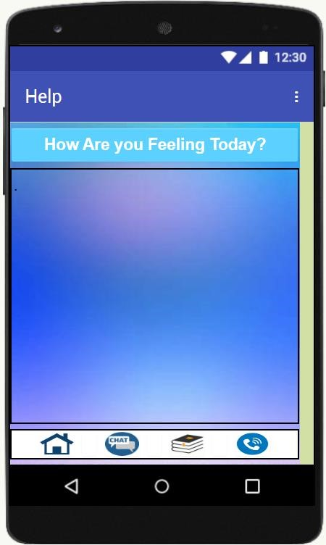

## Figure 2.5: Help Tab

Upon Selecting the how are you feeling on this help tab, the following is an output of mental healthcare descriptions

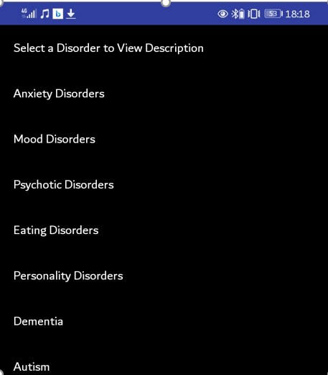

## Figure 2.6: List of Disorders

Upon Selecting one of the disorders on the list for description, the following screen is presented:

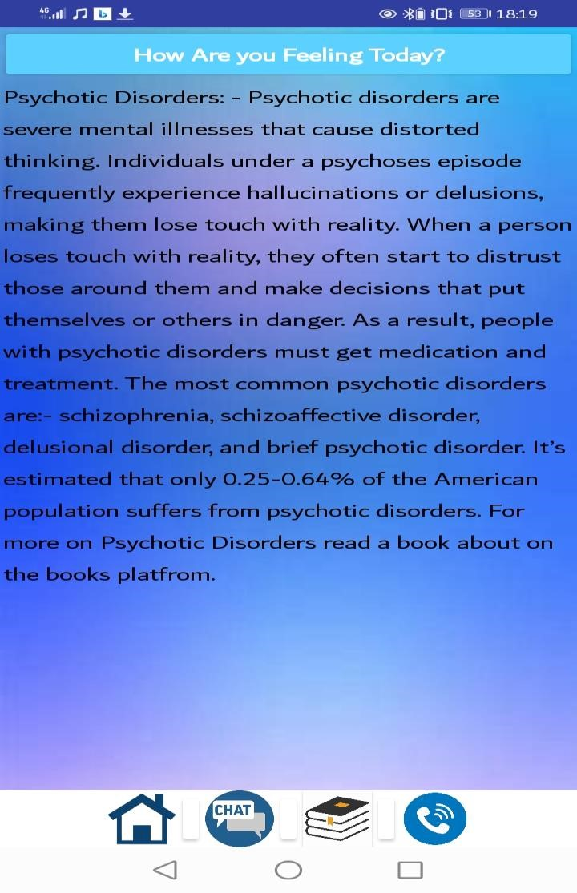

## Figure 2.7: Disorder Description

### 2.6 The Chat Tab

This tab provides a community like platform where when a student or staff has some difficulties and would want to air a problem to other colleagues, there is a provision to write a message and provide a name if the sender wants to be known if the sender is not willing to be known he or she may provide the name coupled with the message. Colleagues may respond to the message as a way of trying to solve a problem. Below is a screen showing some of the messages which were sent whilst testing the app.

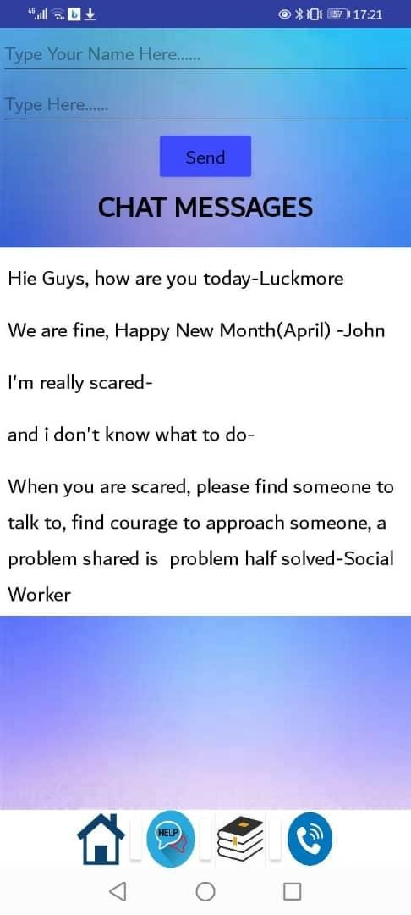

## Figure 2.8: Chat Tab

### 2.7 The Online Links/Books Tab

This tab is responsible for the user to have an extended understanding of how to manage mental health problems, these links and books are embedded in the application and below is a screen to show links to extended content

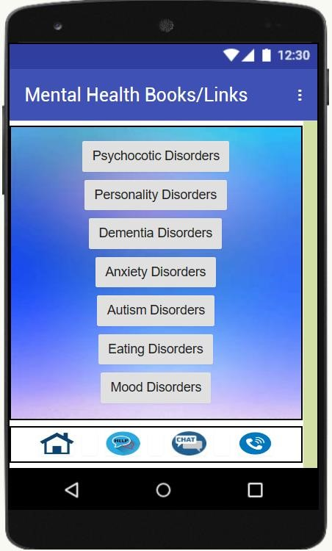

## Figure 2.9: Mental health Links/Books

Upon clicking on one of the links, a redirection to a specified link according to the subject which the user is interested on, the following is an example of a clicked link

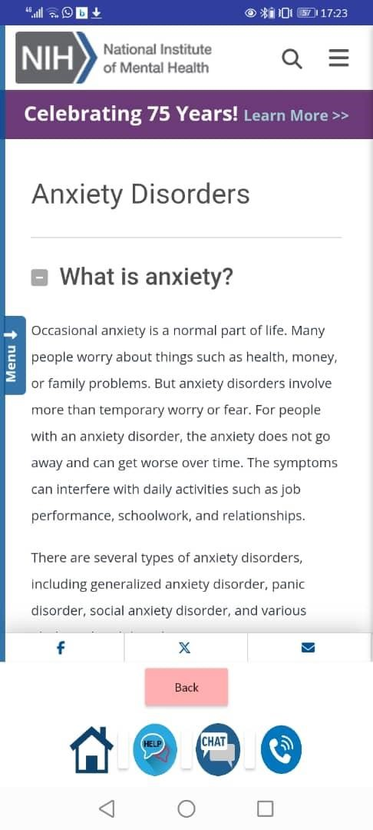

*Figure2. 10: Anxiety Web Page*

### 4.0 Future Tasks

The developer is looking forward to accept various contributions from the team he is working with and also, there are pending tasks on the two applications which need to be perfected

### 4.1 Mental Health Care Application

This application has the following tasks pending to it:

* Development of the call social worker platform
* A request to quiz the user using the Help Tab was requested by one of the users and is still yet a pending task
* A look forward into uploading this application on Google play store

1. American Psychological Association
2.
3. National Institute of Mental Health
4. World health organisation